Alg 3 Summer Name: ____________________________

______________ _____________

WS Assessment

Target 11:

More on Transformed functions

**I can:**

* Transform with absolute
* Transformation of rational function
* **Unit 4: Parent Graphs & Their Transformation**

#### [HSF.IF.B.4](http://www.corestandards.org/Math/Content/HSF/IF/B/4/): For a function that models a relationship between two quantities, interpret key features of graphs and tables in terms of the quantities, and sketch graphs showing key features given a verbal description of the relationship. *Key features include: intercepts; intervals where the function is increasing, decreasing, positive, or negative; relative maximums and minimums; symmetries; end behavior; and periodicity*.*

#### [HSF.IF.C.7](http://www.corestandards.org/Math/Content/HSF/IF/C/7/): Graph functions expressed symbolically and show key features of the graph, by hand in simple cases and using technology for more complicated cases.*

#### [HSF.IF.C.7.B](http://www.corestandards.org/Math/Content/HSF/IF/C/7/b/): Graph square root, cube root, and ~~piecewise-defined functions, including step functions~~ and absolute value functions.

* [**HSF.BF.B.3**](http://www.corestandards.org/Math/Content/HSF/BF/B/3/): Identify the effect on the graph of replacing *f*(*x*) by *f*(*x*) + *k*, *k* *f*(*x*), *f*(*kx*), and *f*(*x* + *k*) for specific values of *k* (both positive and negative); find the value of *k* given the graphs. Experiment with cases and illustrate an explanation of the effects on the graph using technology. *Include recognizing even and odd functions from their graphs and algebraic expressions for them.*

Student.desmos.com classcode =

So far we have learned $f\left(x\right)→af(bx±h)±k$

For a > 1 we have ____________ For b > 1 we have _____________

For 0 < a < 1 we have ____________ For 0 < b < 1 we have ____________

For a < 0 we have ____________ For b < 0 we have ____________

If + h we have ___________ If – h we have _____________

If + k we have ___________ If – k we have _____________

Describe the transformation for the following

|  |  |  |  |  |  |
| --- | --- | --- | --- | --- | --- |
| Function | Hori. Shift  (left/right) | Vert. Shift  (up/down) | Hori.  Strtch/ Comp | Vert.  Strtch/ Comp | Hori. / Vert. Reflection |
| y = (x – 2)2 + 4 |  |  |  |  |  |
| y = 3(2 – x )2 + 3 |  |  |  |  |  |
| y = ½ |  |  |  |  |  |
| Y = 2 | ½ - 3x | – 4 |  |  |  |  |  |
| y = 3 – ½ x2 |  |  |  |  |  |
| y = |  |  |  |  |  |
| y = 2 + 2x – 3 |  |  |  |  |  |
| y = 2 – 2e3-.5x |  |  |  |  |  |

Describe the transformation converts the graph of

f(x) = - ½ |x + 2| - 6 into the graph g(x) = |x -3| + 2 ?

f(x) = 2 (x – 4 )2 + 3 into the graph g(x) = - (x + 2 )2 – 5 ?

f(x) into the graph g(x) = 2f(x – 2) + 3

f(x) into the graph g(x) = 2 – ½ f(1 – x)

2f(x – 1 ) into the graph g(x) = 2 – ½ f(1 – x)

Write both parent function and child function that being transformed as shown.

Graph both of them on the calculator for stamp

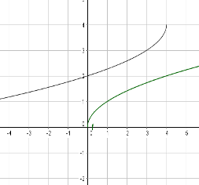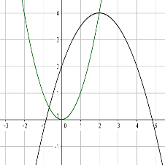

Absolute transformation

Sketch the graph f(x) = (x – 2)2 – 2 and g(x) = |f(x)|

Now given the graph f(x) below, sketch the graph g(x) = |f(x)|

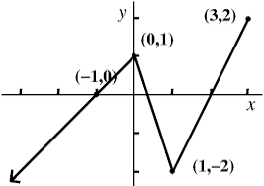 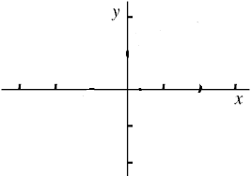

Describe the transformation f(x) to |f(x)| in words

Absolute transformation

Sketch the graph f(x) = (x – 2)2 – 2 and g(x) = f(|x|)

Now given the graph f(x) below, sketch the graph g(x) = f(|x|)

 

Describe the transformation f(x) to |f(x)| in words

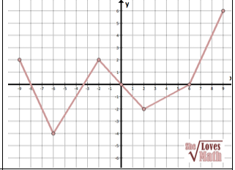Now you do. Given the graph function f(x) sketch the graph

g(x) = |f(x)| and

h(x) = f(|x|).

Show me all three in desmos for stamp

Rational function

Given function f(x) = $\frac{1}{x}$. Write the function that translate. Sketch on the given graph (desmos)

|  |  |  |  |
| --- | --- | --- | --- |
| 2 units up  g(x) =? | 3 units down  g(x) =? | 2 units left  g(x) =? | 3 units right  g(x) =? |
|  |  |  |  |

Describe the following transformation from parent graph f(x) = $\frac{1}{x}$ (desmos may help)

|  |  |  |
| --- | --- | --- |
| f(x) = $\frac{1}{x+1}+2$ | f(x) = $\frac{1}{x-1}-2$ | f(x) = $3+\frac{1}{x+1}$ |
| f(x) = $2-\frac{1}{x+1}$ | f(x) = $2-\frac{1}{1-x}$ | f(x) = $2-\frac{2}{1-x}$ |

Describe the following transformation from parent graph f(x) = $\frac{1}{x}$ to

$$\frac{x+2}{x+1}$$

$$\frac{x-2}{x+1}$$

$$\frac{2x+4}{x+1}$$

**Assessment Target 11**

**I can…** perform transformation

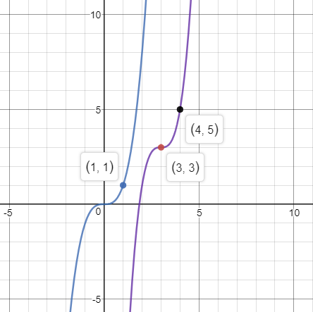

Show this graph in desmos for stamp

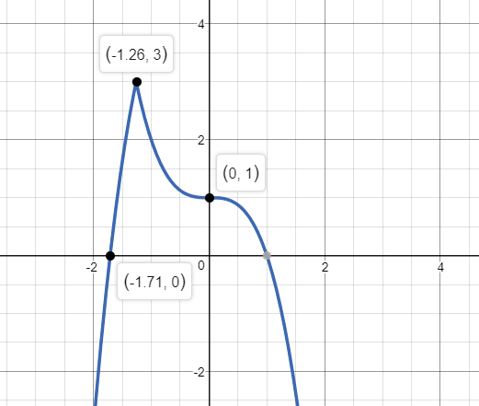This parent function is f(x) = x3 is transformed into the following graph. Show me for stamp

The parent graph is $f\left(x\right)=\frac{1}{x}$ Show the steps to perform the transformation into $g\left(x\right)=\frac{3x-5}{x-1}$